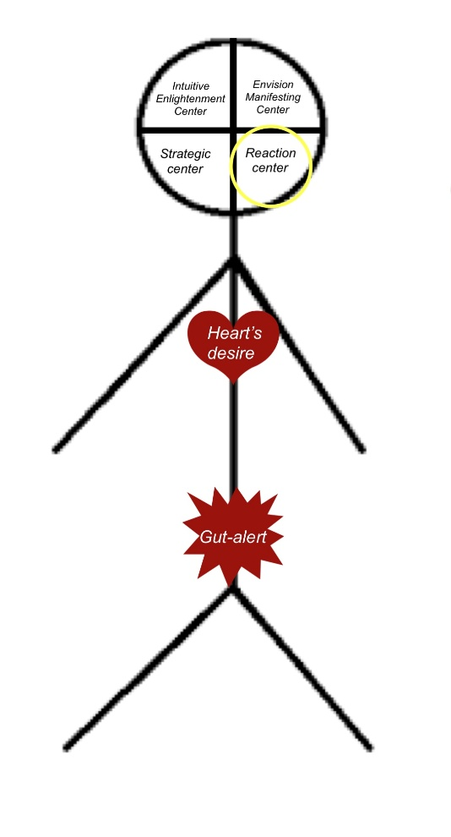
The first place the transmitters from our gut-alert go is to the reaction center in our brain: the amygdala. This sends us into a fight, flight, or freeze reaction because those immediate situations bring up older unconscious beliefs that make us wonder if we are enough to handle the situation at hand. Beliefs create thoughts, which activate emotions, which in turn determine how we behave. At it’s those behaviors/actions that determine the results in our life. So in order to not react, we have to get down to the beliefs that are getting in the way. It’s like doing a Norton Virus Scan, eliminating what is causing our operating system to be inefficient, so we can replace the old beliefs with new programming.
Beliefs around Safety, Security, and Capability: What belief is telling you that you are not enough to keep yourself safe and secure—because you are not capable enough?
Click or tap here to enter text.
Beliefs around Love and Belonging: What belief is telling you that you are not lovable enough to belong—because somehow you are not lovable enough?
Click or tap here to enter text.
How will you notice when these beliefs are activated: Body Sensations? Self-Talk? Behavior?
Click or tap here to enter text.

