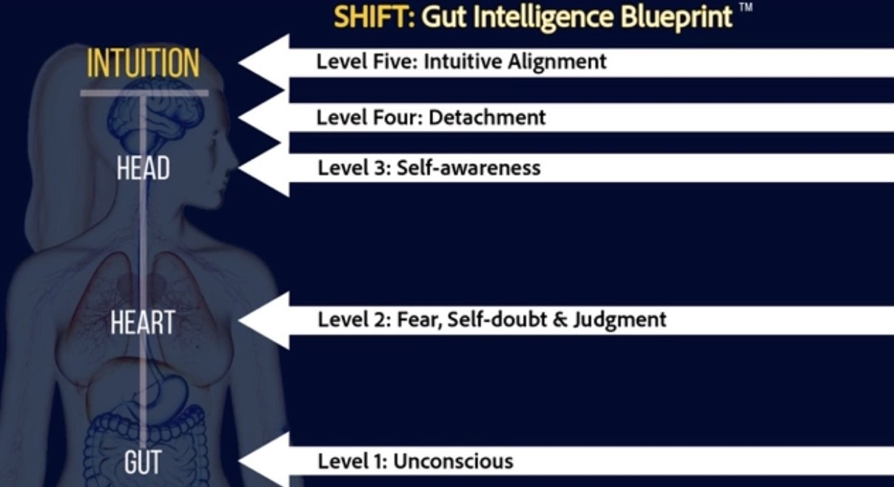
Check in with yourself periodically, as things can change in your life. When we face uncertainty, we tend to operate at lower levels of consciousness. Ask yourself, “What level of consciousness am I operating at right now?
Level One: Unconscious. Where are you operating unconsciously, perhaps being so busy or distracted that you are not paying attention to those gut-alerts, how you feel, and if you are in alignment? What are you doing to stay unconscious?
Click or tap here to enter text.
Level Two: Fear, self-doubt, and Judgment. Where are you perhaps facing a new situation, uncertainty, or stretching to your next level that is causing you to feel fear, self-doubt, and judgment? What does it sound like?
Click or tap here to enter text.
Level Three: Self-awareness. Where are you aware that your E.G.O. is chattering, but you are not yet able to detach from it? Where might there be a stronghold of an old belief, telling you that you are “not enough?”
Click or tap here to enter text.
Level Four: Detachment. Where are you ready to detach from those old beliefs holding you back?
Click or tap here to enter text.
Level Five: Intuitive Alignment. Where are you ready to become intuitively aligned, allowing your intuition to guide you to your next level of you?
Click or tap here to enter text.
Overall, what level of consciousness do you believe you are operating at?:
Work: Click or tap here to enter text.
Home: Click or tap here to enter text.

